# Acceptance Criteria Testing

## Story ID 3

User Story: As the owner I want to see and track the delivery times of packages for each driver so that I know if my employees are working at peak efficiency

* I can view a list of all past deliveries made.
* I can view when the driver departed for a delivery.
* I can view when the driver made the journey.
* I can view the total time of the journey.

I can view a list of all past deliveries made.

I can view when the driver departed for a delivery

I can view when the driver made the journey.

I can view the total time of the journey.

Jeff Jefferson is gone

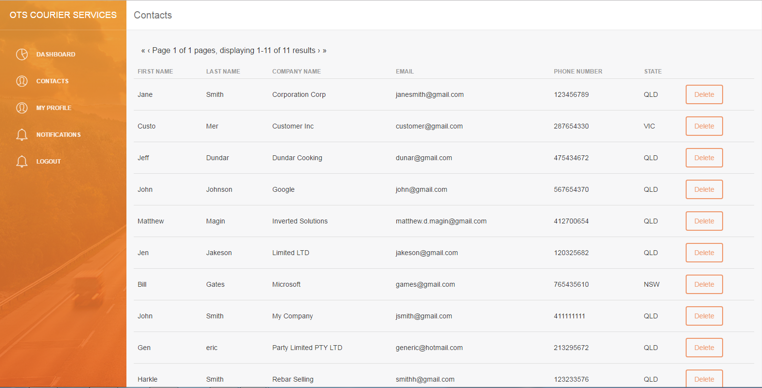

NOT IMPLEMENTED → ADD CONTACT

During development, it was found since the current iteration of the contacts page draws from the customers table and adding a contact would effectively create an account for them (complete with a password) either this function needs to be available to the customers themselves or be retooled to use a different table.